Michael Johnathon: Pandemics, Painting & Possibilities
Merging Music, Art, Songwriting ... and the 2020 Milner Award
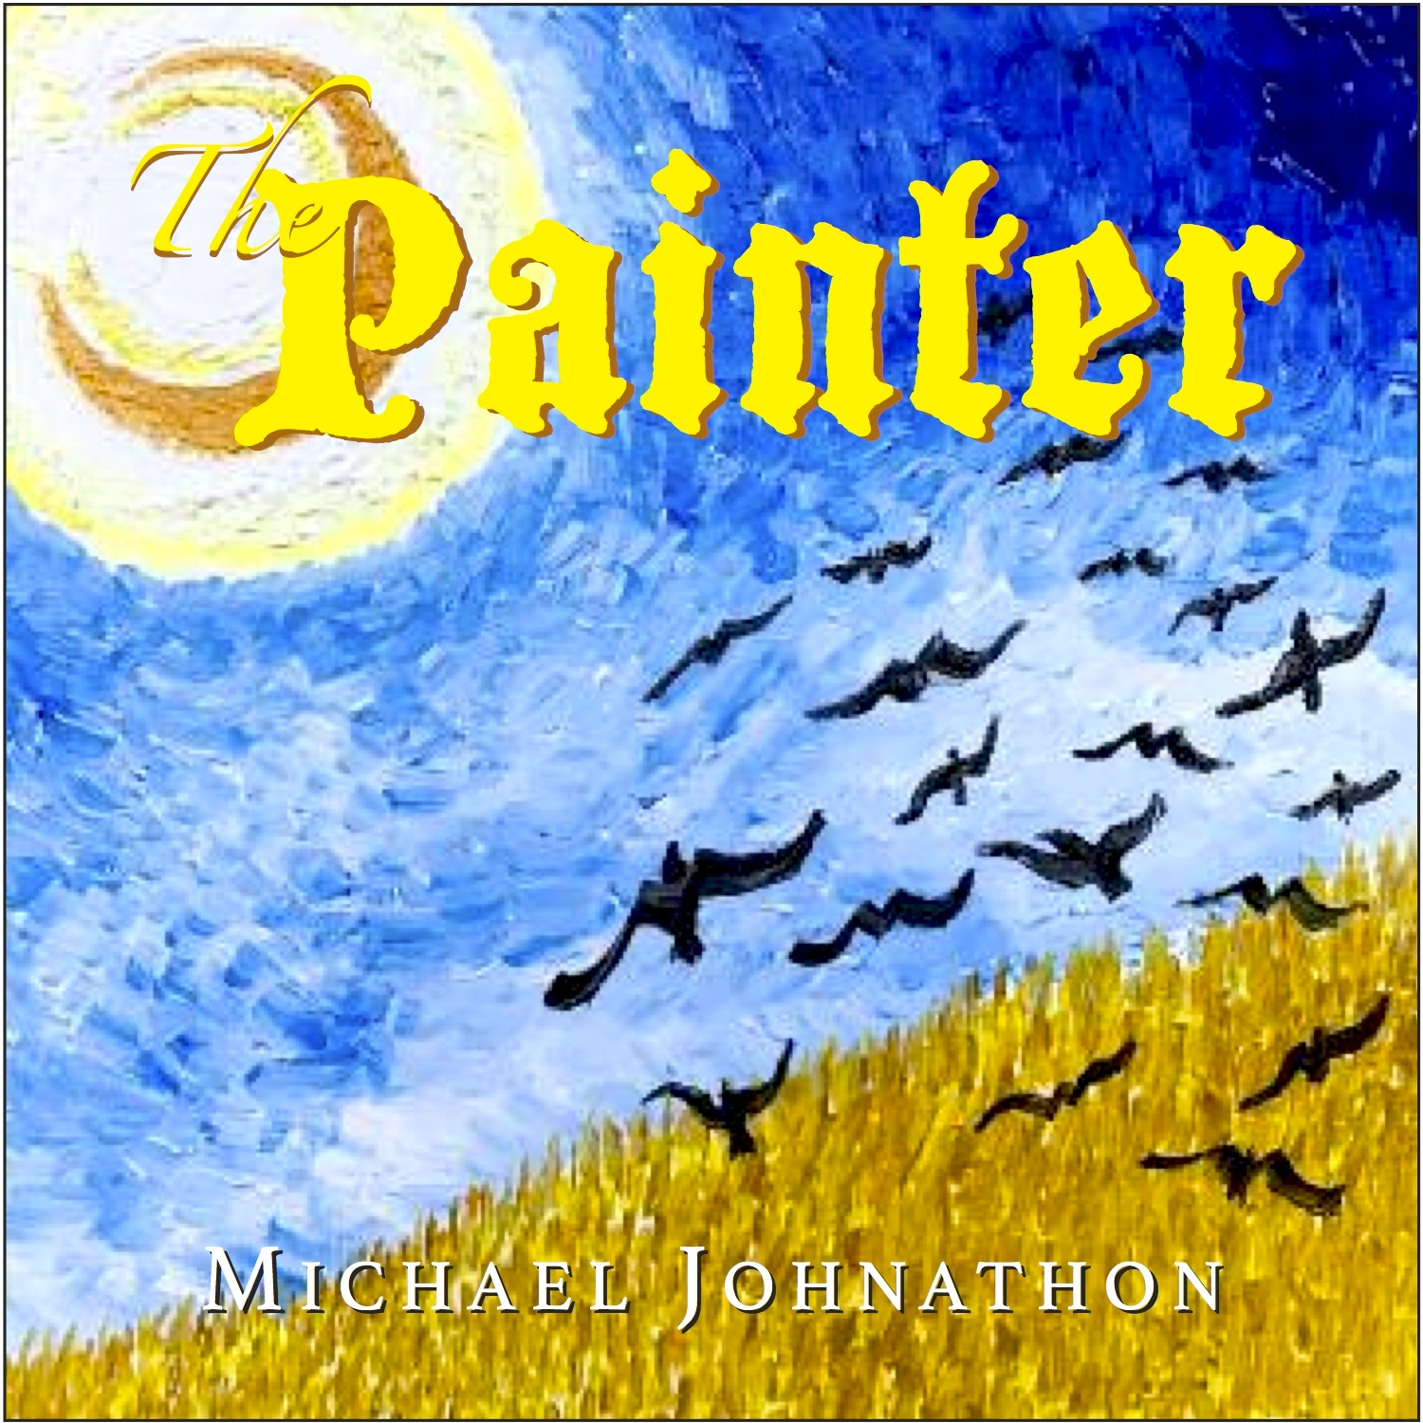
Lexington, KY - The venues for all art forms have been darkened during this pandemic with the closures of live music venues, outdoor concerts and festivals. Folksinger, poet and author Michael Johnathon has turned to oil painting during this time of isolation, inspiring a brand new song cycle and album, The Painter.
His reputation as a renaissance artist is well established. As a teenager he had a comic strip published in 17 newspapers. Johnathon picked up the guitar and moved to the Appalachia mountains, becoming immersed in the music of America’s front porch. He is a touring songwriter with 17 released albums, five published books, playwright of the Walden Play performed in 42 countries, composer of the traditional opera, Woody: For the People. He organized the national association of front porch musicians called SongFarmers, now with 73 active chapters nationwide.
An adventurous performer, Michael filmed a concert special for public television and radio nationwide and the RFD TV Network with The Ohio Valley Symphony called “Songs of Rural America,” celebrating the music of America’s front porch.
He is the creator and host of the live audience broadcast of the WoodSongs Old Time Radio Hour with a radio audience with over two million listeners each week on 500 public radio stations, public TV coast-to-coast, American Forces Radio Network in 173 nations and the RFD-TV Network nationwide. WoodSongs produced its historic 1000th live audience broadcast November 2019 (WoodSongs.com/WS1000) WoodSongs has brought the spirit of America’s front porch to radio and TV around the globe and the live audience broadcast has been produced in theatres from Arkansas to Ireland and from its home base at the Lyric Theatre in Lexington. WoodSongs now has a major display for the public at the Kentucky Music Hall of Fame at Renfro Valley.
Along the way Johnathon released his fully illustrated book introducing kids to bluegrass music called Mousie HiWay: The Adventures of Banjo Mouse.
Then the pandemic hit ... and the music world came to a complete halt.
“All touring stopped. The business of music stopped. But, art is born of isolation, so during this isolated, quiet time, an artist supposedly should do their best work, right?” he says from his rural log cabin home in Kentucky.
So, he went to work and studied the syles of masters like Rembrandt, Michelangelo and Monet. When it came time for Johnathon to put his own brush to canvas, he settled on the influence of Vincent van Gogh “Because his brilliance is in his simplicity,” he explains,“ Vincent was so simple that it was complicated.” Johnathon was drawn in by the imperfection, movement of the work and the spirit of van Gogh’s brush.
“Vincent is to the art world as Woody Guthrie and Bob Dylan are to the music world,“ Johnathon explains. “As a folksinger I get what makes their music so revered. Besides the power of their lyrics, it’s the accessibility of their songs. They’re simple, everybody wants to play them. That is the simplicity that I loved. I wanted my paintings to feel just as accessible. That is why I used van Gogh as a mentor, not to copy him, but to use his inspiration.”
The Painter song cycle, the album and the 2020 Milner Award
To date, Johnathon has produced 34 oil paintings since the pandemic started from his art studio in his Kentucky log cabin home. Several of his original works merge landscapes and sky with music themes as in his titles of “Banjo Galaxy”, “Pete (Seeger) My Old Brown Earth”, and “Starry, Starry Note” plus the cover of the new album, “The Painter.” (see MichaelJohnathon.com/art)
Painting inspired Johnathon to write the songs for his next CD “The Painter,” a song cycle about art, artists, love and life. The title cut is also the theme song of the ongoing work for a motion picture script he is writing of the same name, about Vincent van Gogh coming back in 2022 to see his despised work now revered worldwide. The music for the album was inspired by Johnathon’s efforts creating oil paintings. Merging music, painting, and writing seemed natural, so the album will be packaged with his next book release, WoodSongs 5 in 2021.
“To me, The Painter is a song cycle about the idea of the blank canvas being filled with all the colors of life. Art, music, painting, family, love, loss and the energy of seeking the next thing. Maybe that next thing is God, I don’t know.”
The title cut is a derivative of the classic Vincent (Starry, Starry Night), the two songs act as bookends on the album. The timely plea of The Statement is balanced by Harry Chapin’s powerful Cats In The Cradle, embellished by, of all things, a hammer dulcimer. Dylan’s plaintive Make You Feel My Love is in lyrical contrast to Johnathon’s own Blues Tonight. Vincent In The Rain creates the imagery of Van Gogh’s search for love in France, while Othello merges the deception in the Shakespeare play with the idea of the deception of a blank canvas, creating what was not there.
As the pandemic subsides and the music world finds renewal, Michael Johnathon hopes to do a national concert tour of art galleries and museums to introduce his oil painting gallery and the songs from the new album.
The 2020 Milner Award
The highest honor given to any artist in Kentucky is presented by the Governor and the Kentucky Arts Council for outstanding achievements in the arts. Michael Johnathon was selected by Governor Beshear to receive the 2020 Milner Award.
“To stand in the company of Wendell Berry, Jesse Stewart, icons like Jean Richie, Homer Ledford and so many other proud artists of Kentucky, it is deeply moving and I am more than grateful,” he says. “It is a great statement that, in the perils of a pandemic, the economic slowdown and everything else that we deal with Kentucky continues to honor and support the importance of the arts. The arts is more than the economy and tourism, it represents the quality of life.”
A new album, songwriting, oil painting, an opera, a performance play, screen writing, an upcoming book, a international radio and TV broadcast, a national association of front porch musicians, 6 year old twins and a log cabin in Kentucky and now a major award.
“The world is a canvas of our imagination,” said Henry David Thoreau.
Welcome to the canvas of Michael Johnathon.
<END>
Details: MichaelJohnathon.com/ThePainterCD
INTERVIEW & MEDIA contact: Loretta Sawyer ph: 312-391-7605 email: WriteLor@aol.com

